1. Create a new process by invoking the appropriate system call. Get the process identifier of the currently running process and its respective parent using system calls and display the same using a C program.

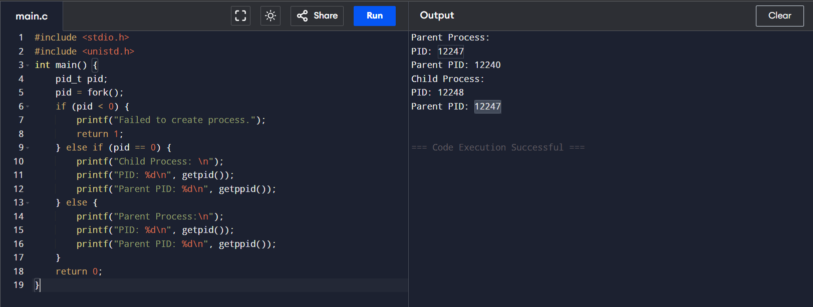Code:

1. Identify the system calls to copy the content of one file to another and illustrate the same using a C program

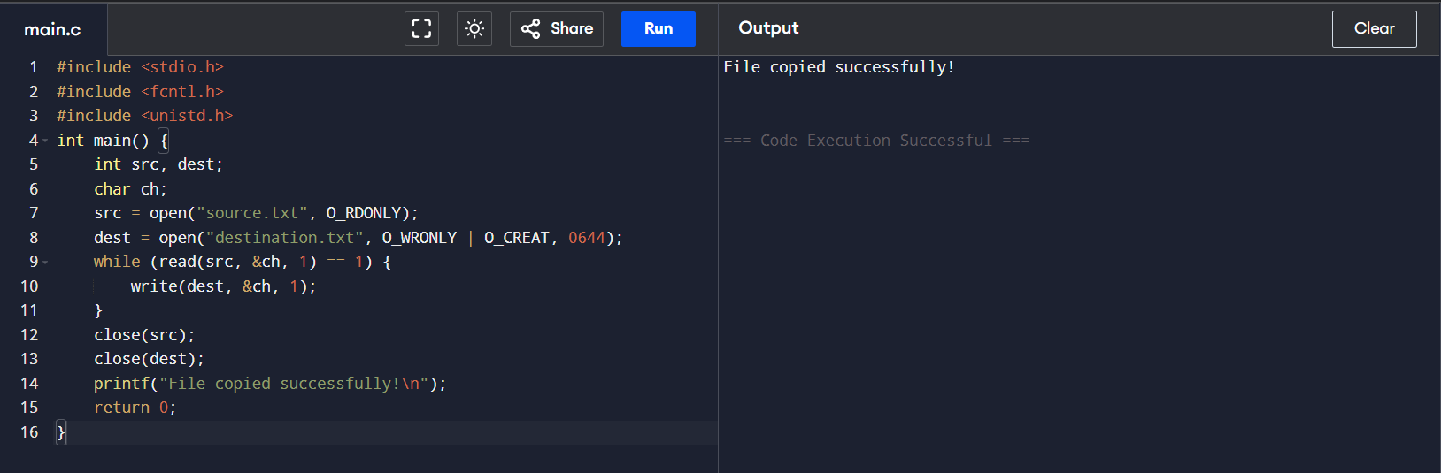

1. 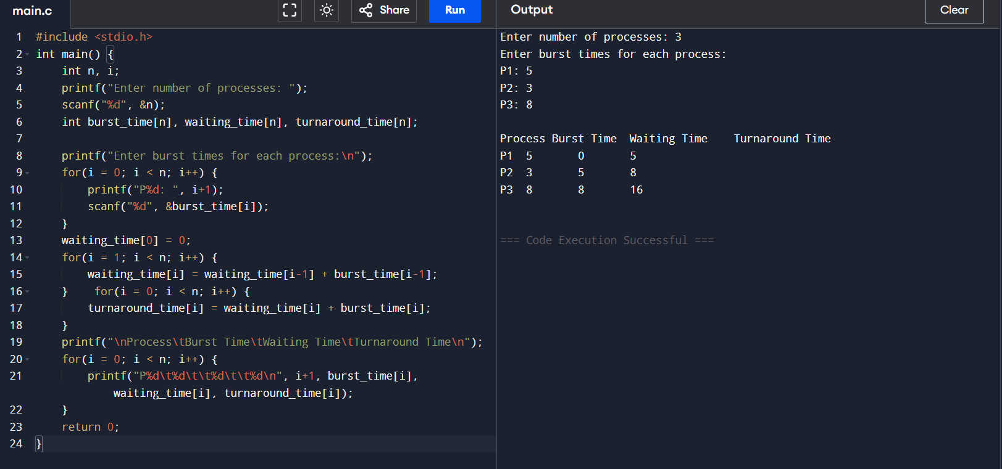Design a CPU scheduling program with C using First Come First Served technique with the following considerations. a. All processes are activated at time 0. b. Assume that no process waits on I/O devices.
2. 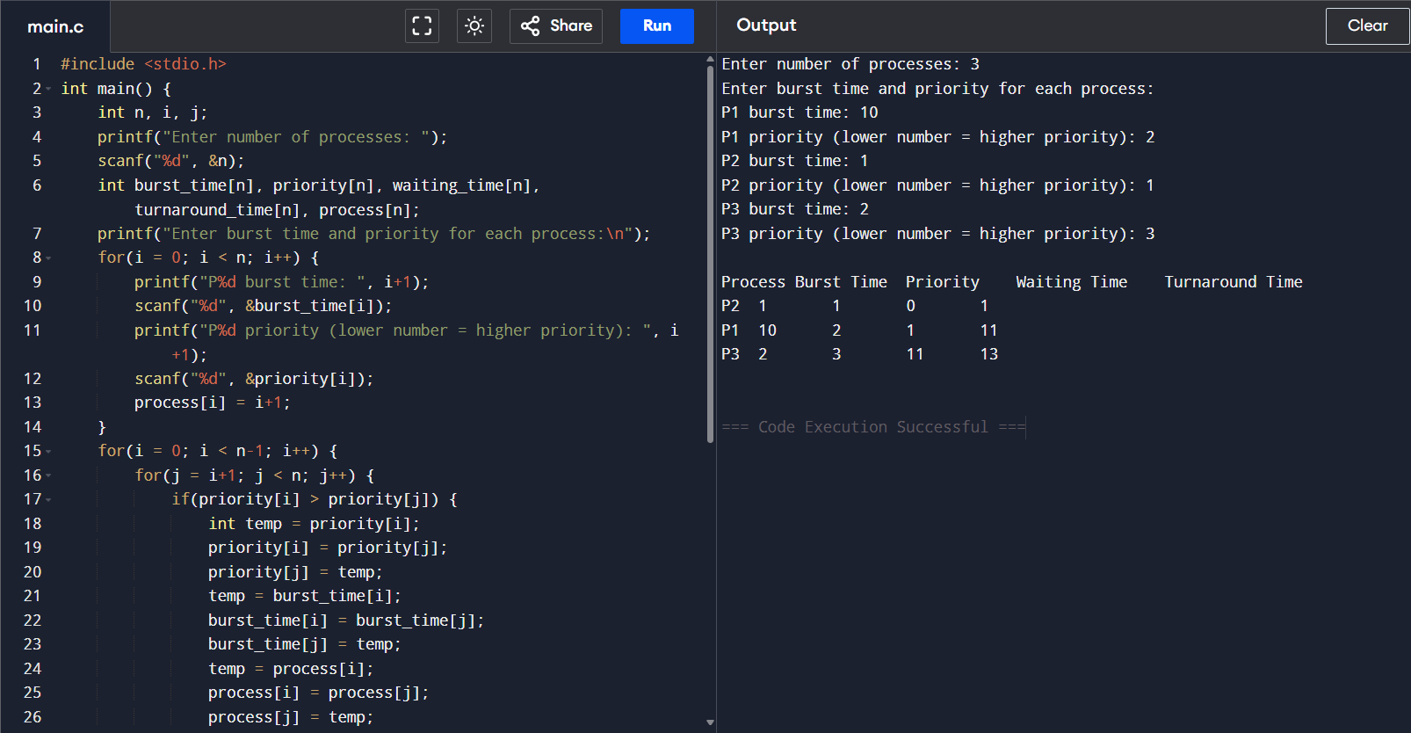Construct a scheduling program with C that selects the waiting process with the smallest execution time to execute next.
3. Construct a scheduling program with C that selects the waiting process with the highest priority to execute next.

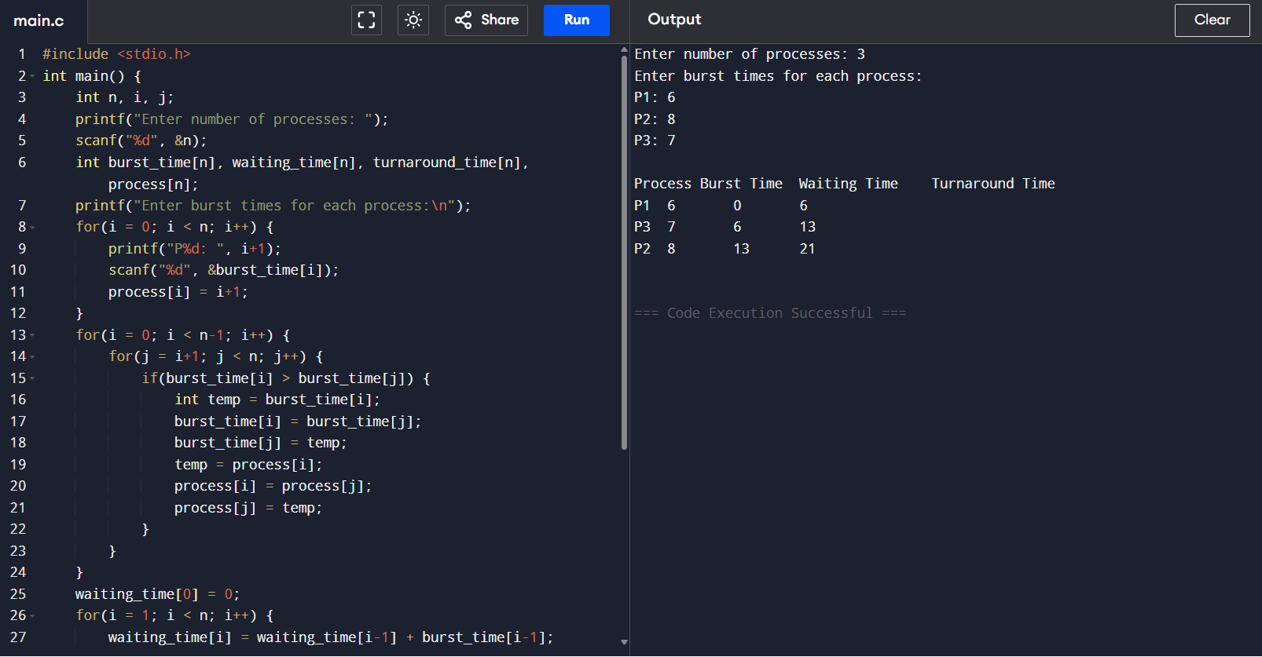

1. Construct a C program to implement pre-emptive priority scheduling algorithm.

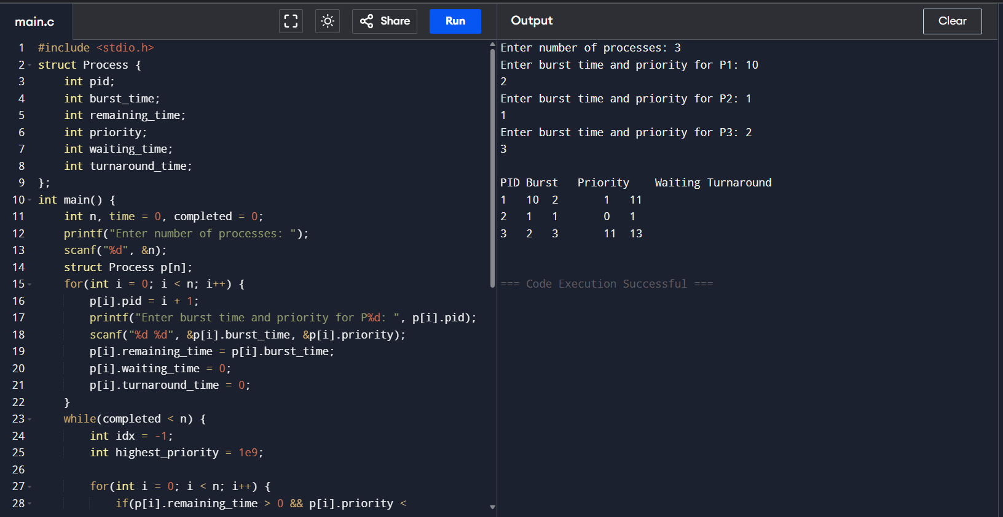

1. 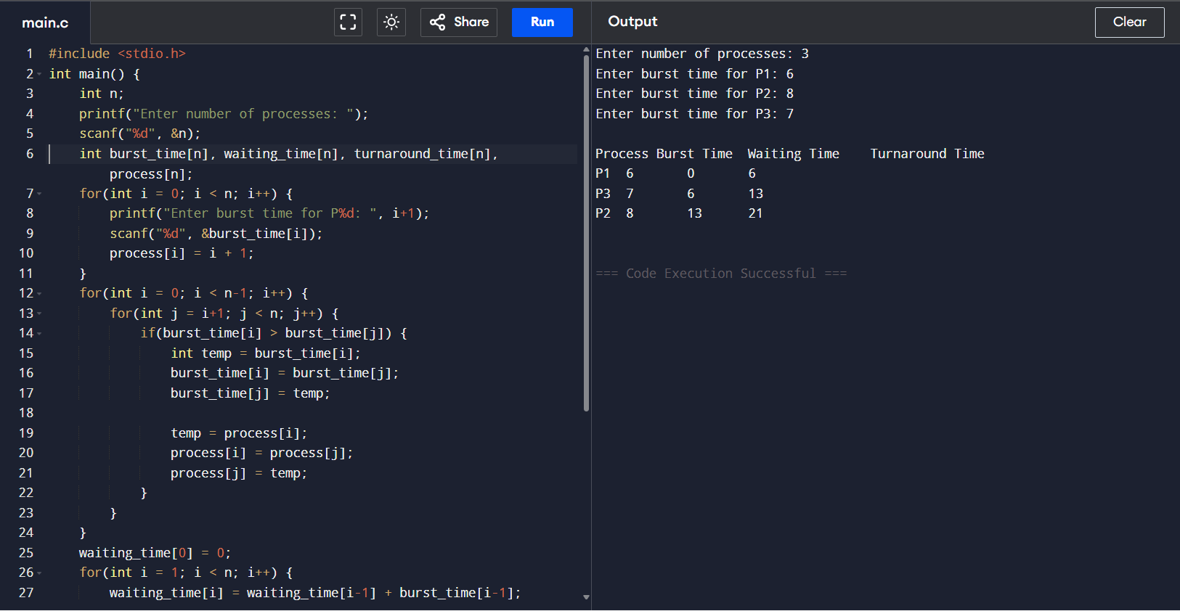Construct a C program to implement non-preemptive SJF algorithm.
2. 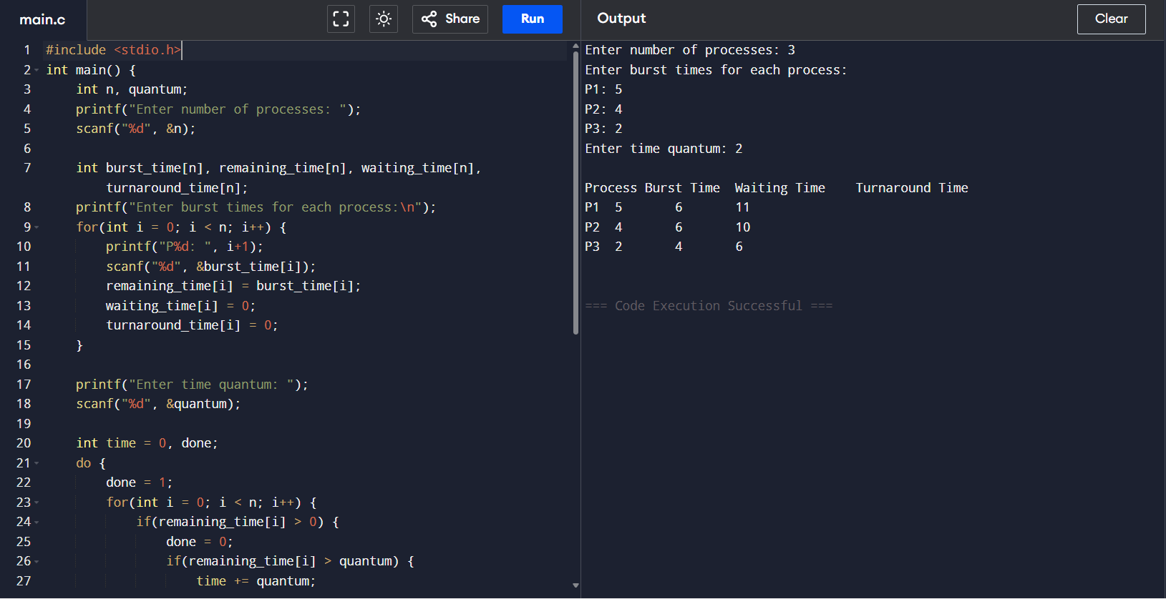Construct a C program to simulate Round Robin scheduling algorithm with
3. 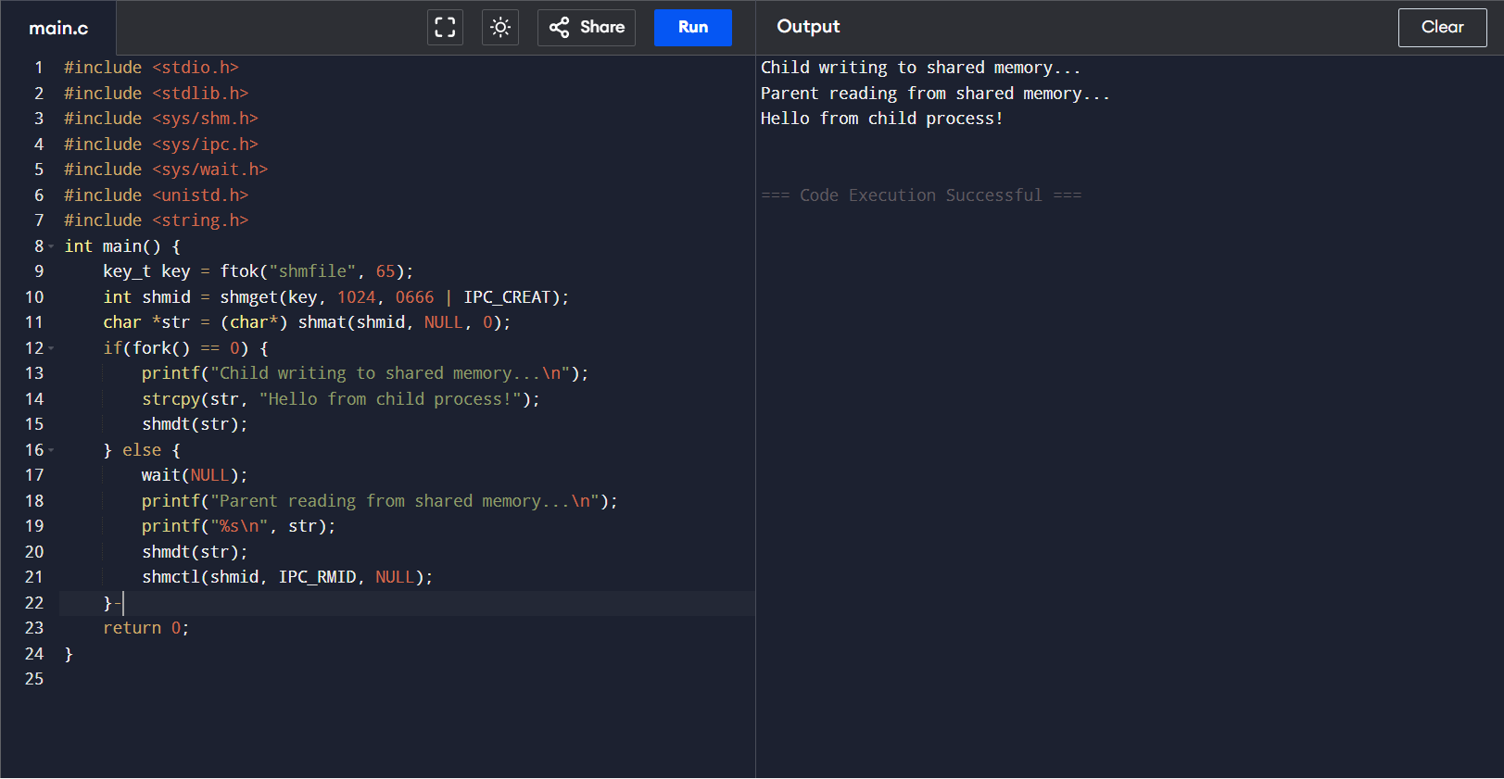Illustrate the concept of inter-process communication using shared memory with a C program.

10. Illustrate the concept of inter-process communication using message queue with a C program.

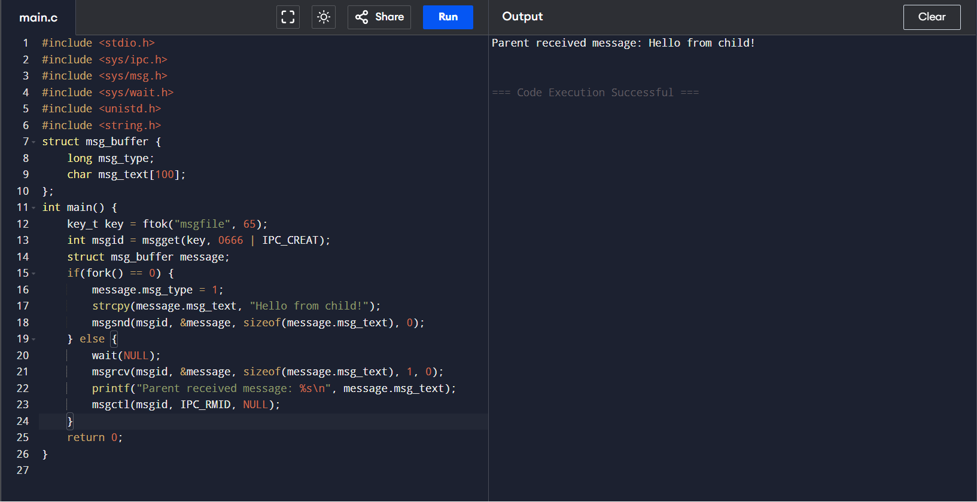

1. 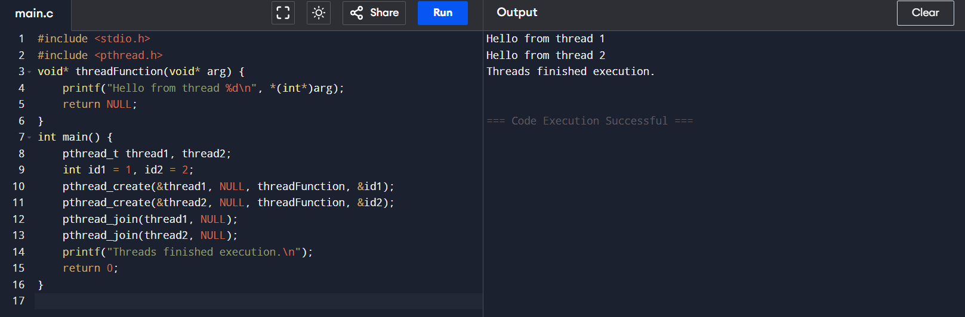Illustrate the concept of multithreading using a C program.
2. Design a C program to simulate the concept of Dining-Philosophers problem

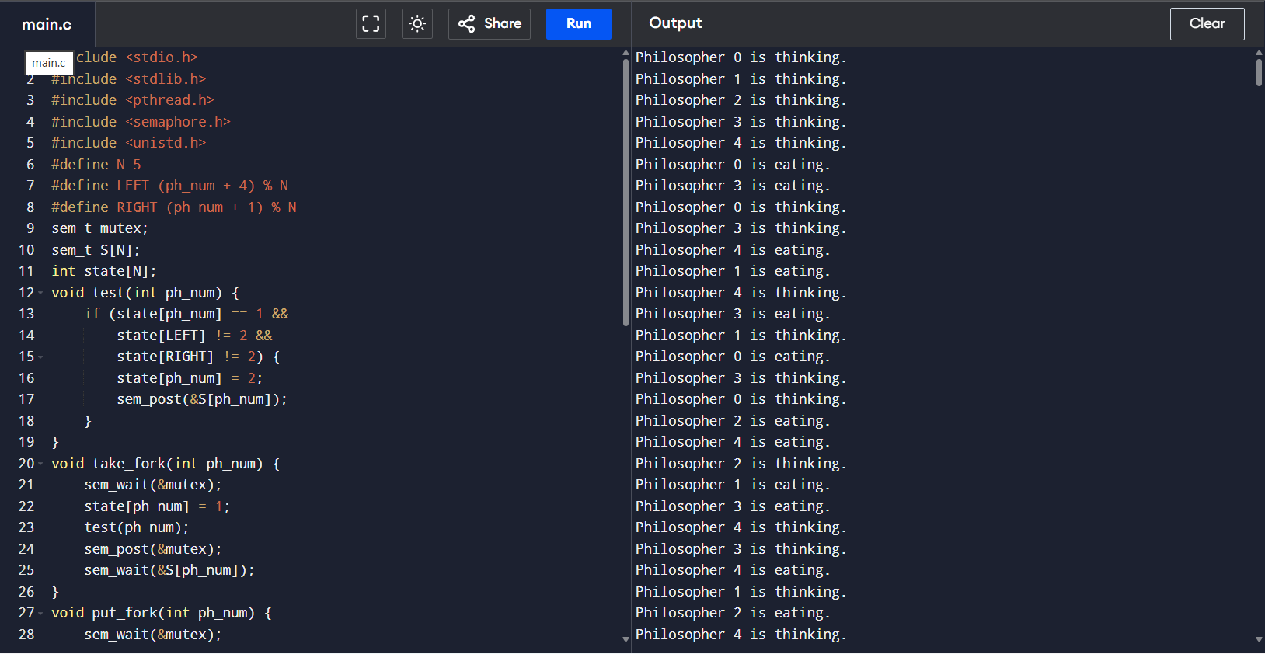

1. 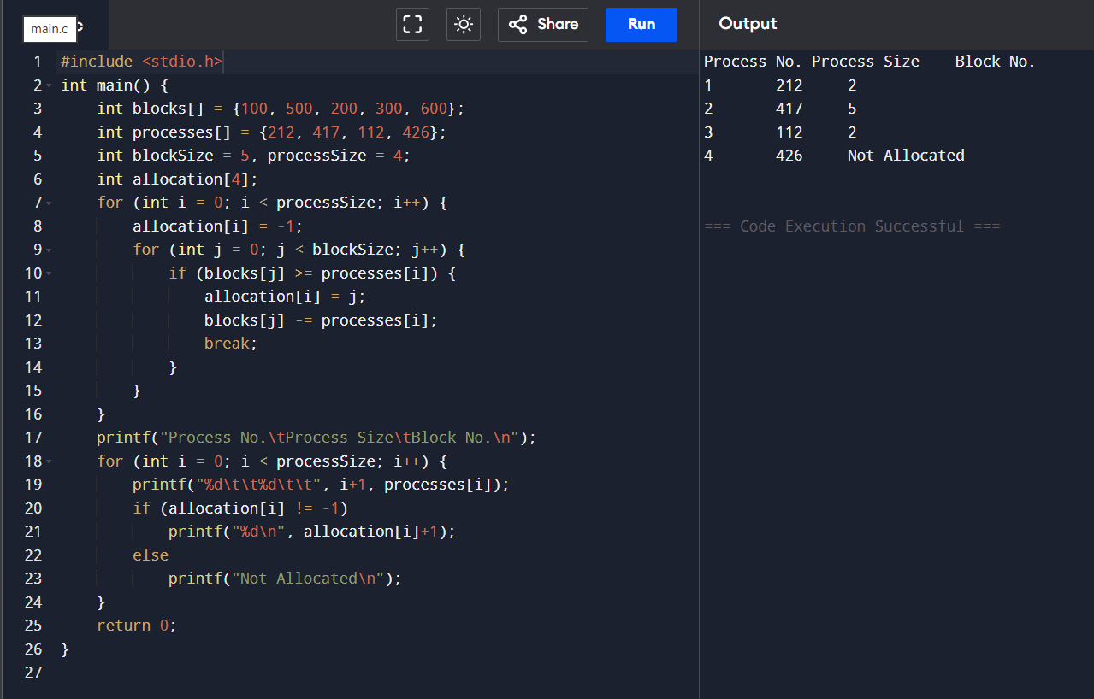Construct a C program for implementation the various memory allocation strategies.
2. Construct a C program to organize the file using single level directory.

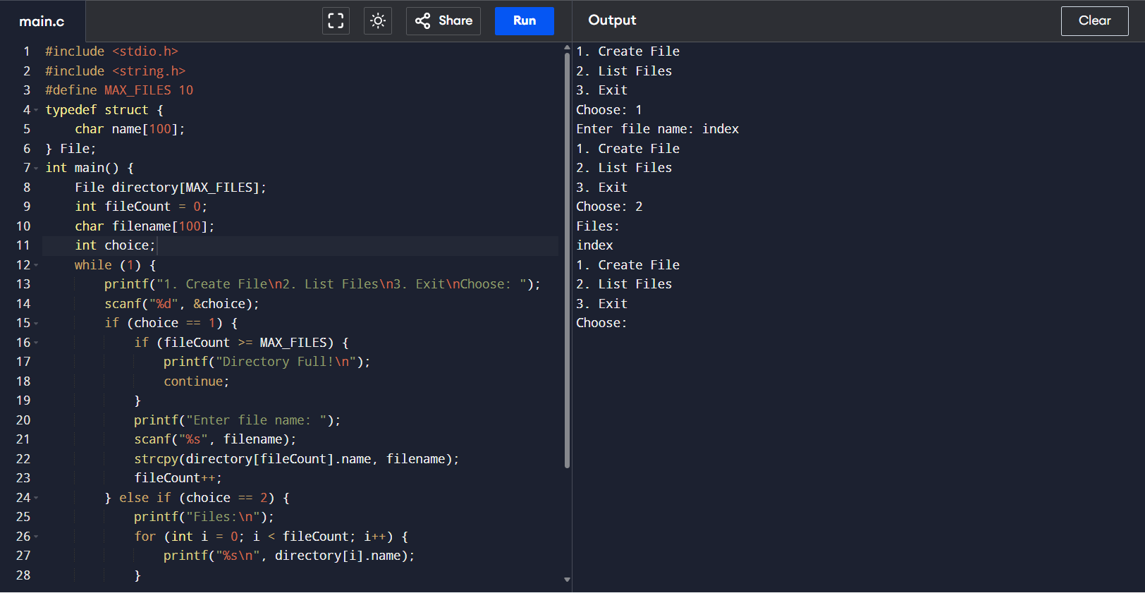

1. Design a C program to organize the file using two level directory structure.

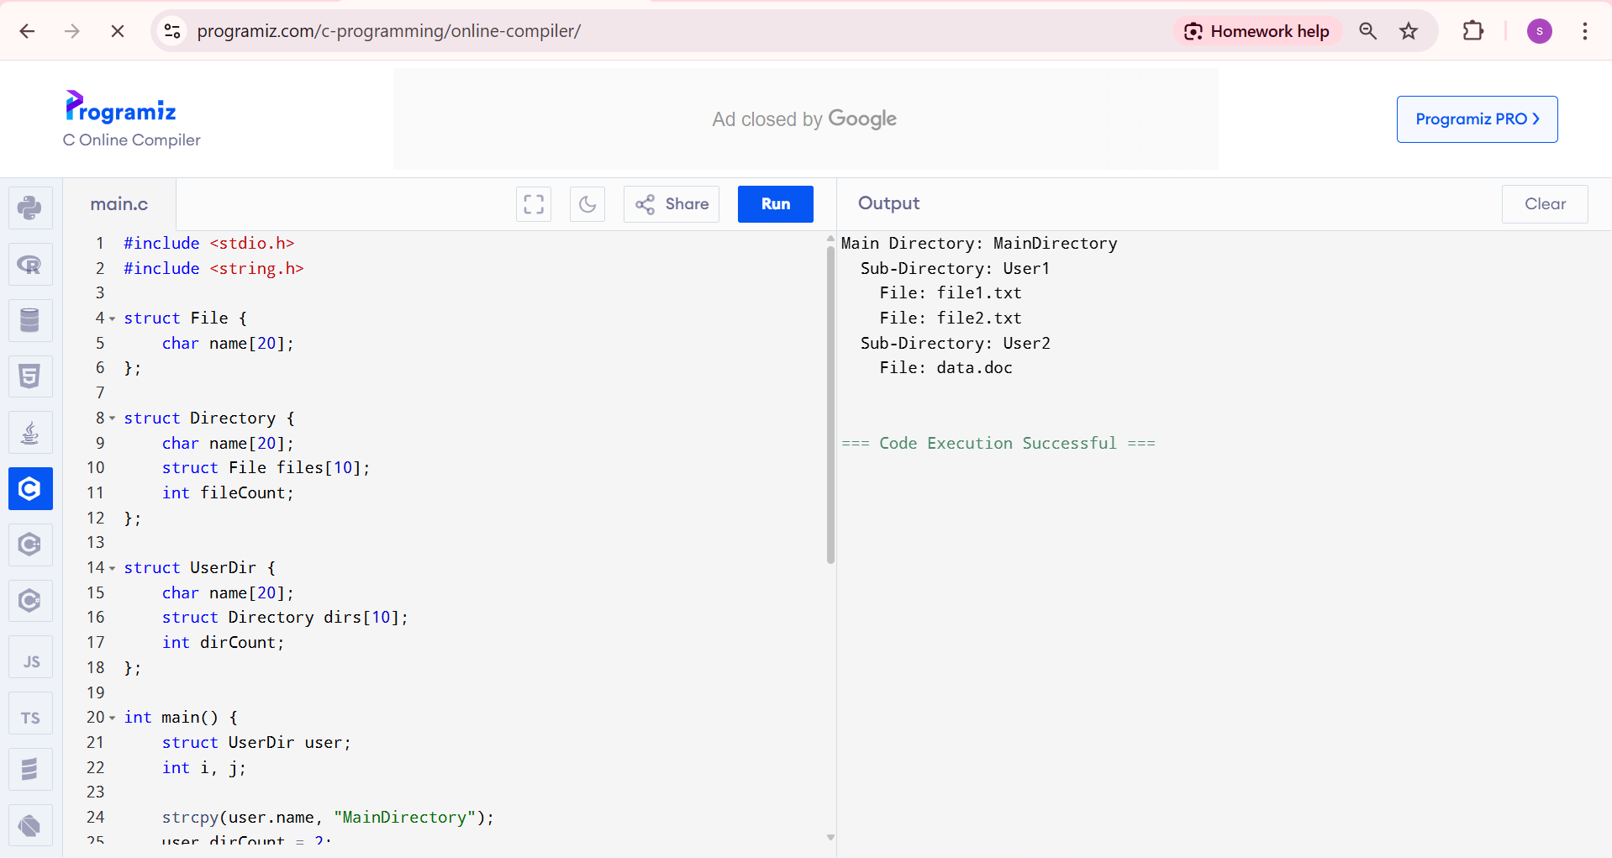

16. Develop a C program for implementing random access file for processing the employee

details.

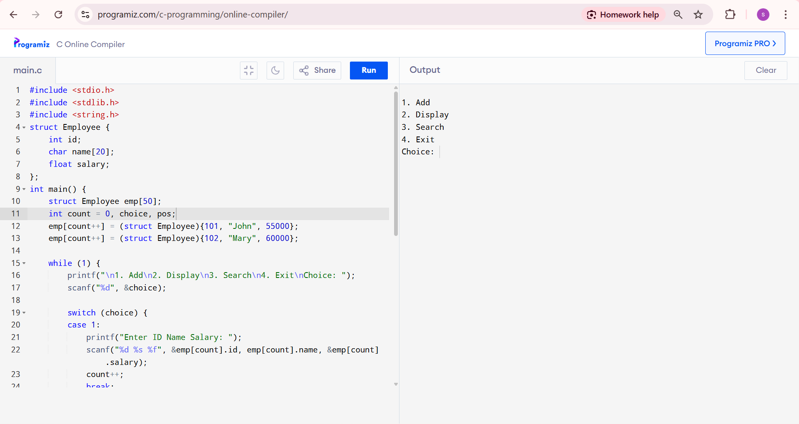

17.Illustrate the deadlock avoidance concept by simulating Banker’s algorithm with C.

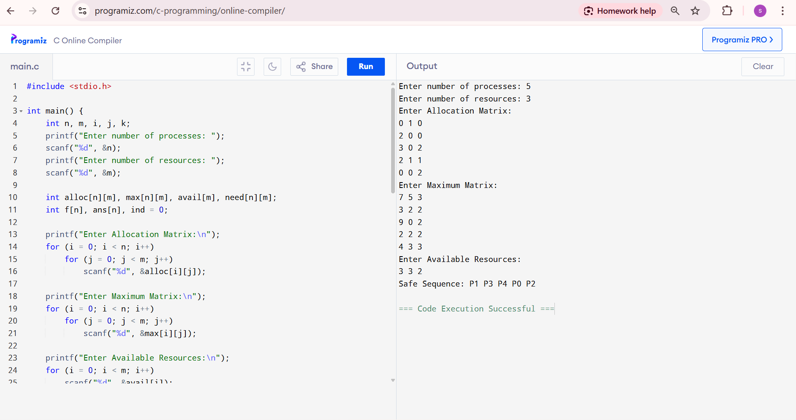

18 Construct a C program to simulate producer-consumer problem using semaphores.

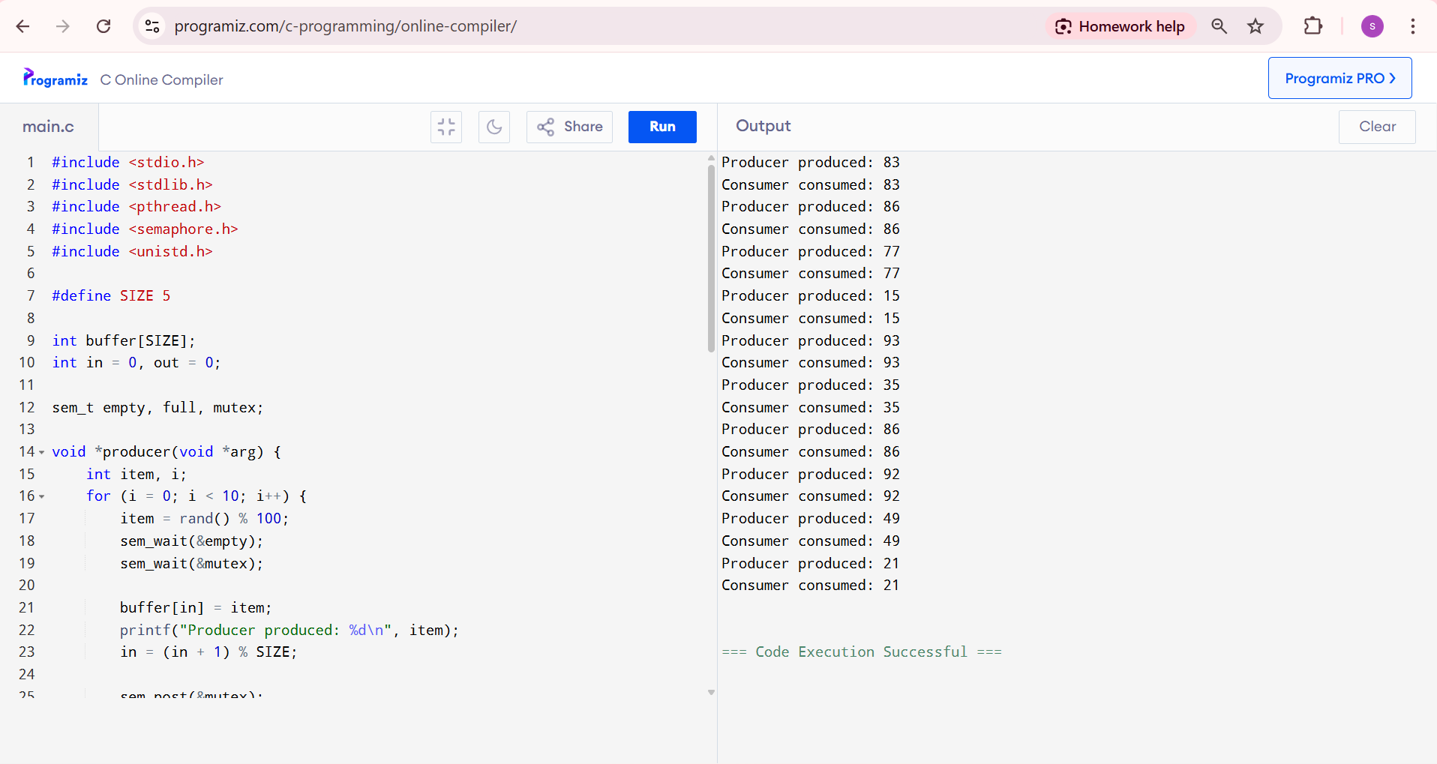

19. Design a C program to implement process synchronization using mutex locks.

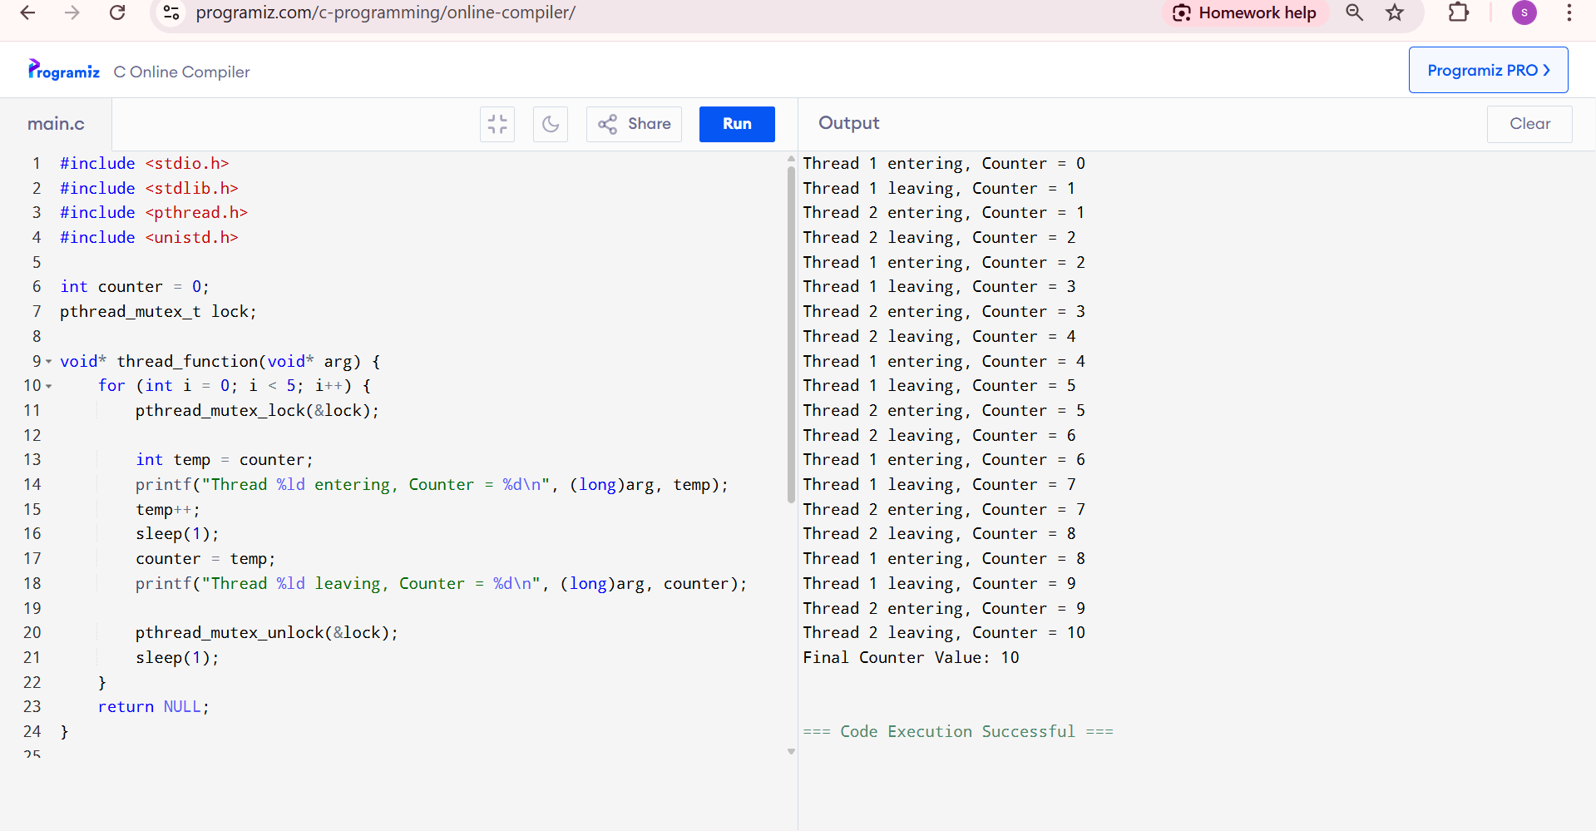

20. Construct a C program to simulate Reader-Writer problem using Semaphores.

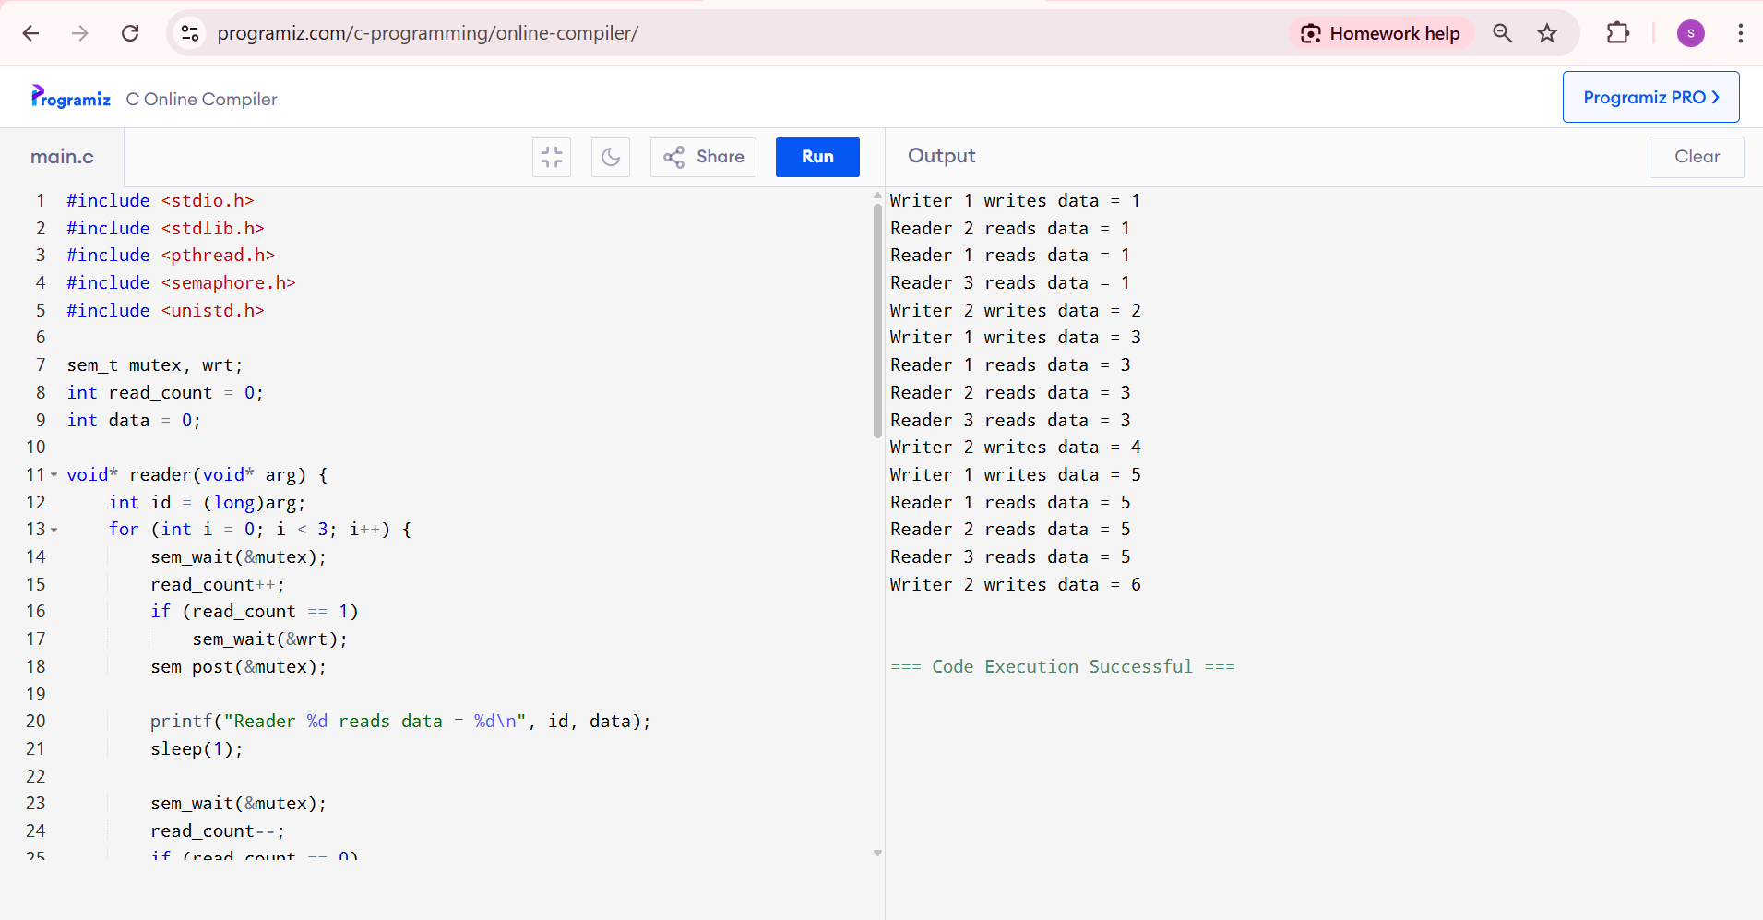

21. Develop a C program to implement worst fit algorithm of memory management.

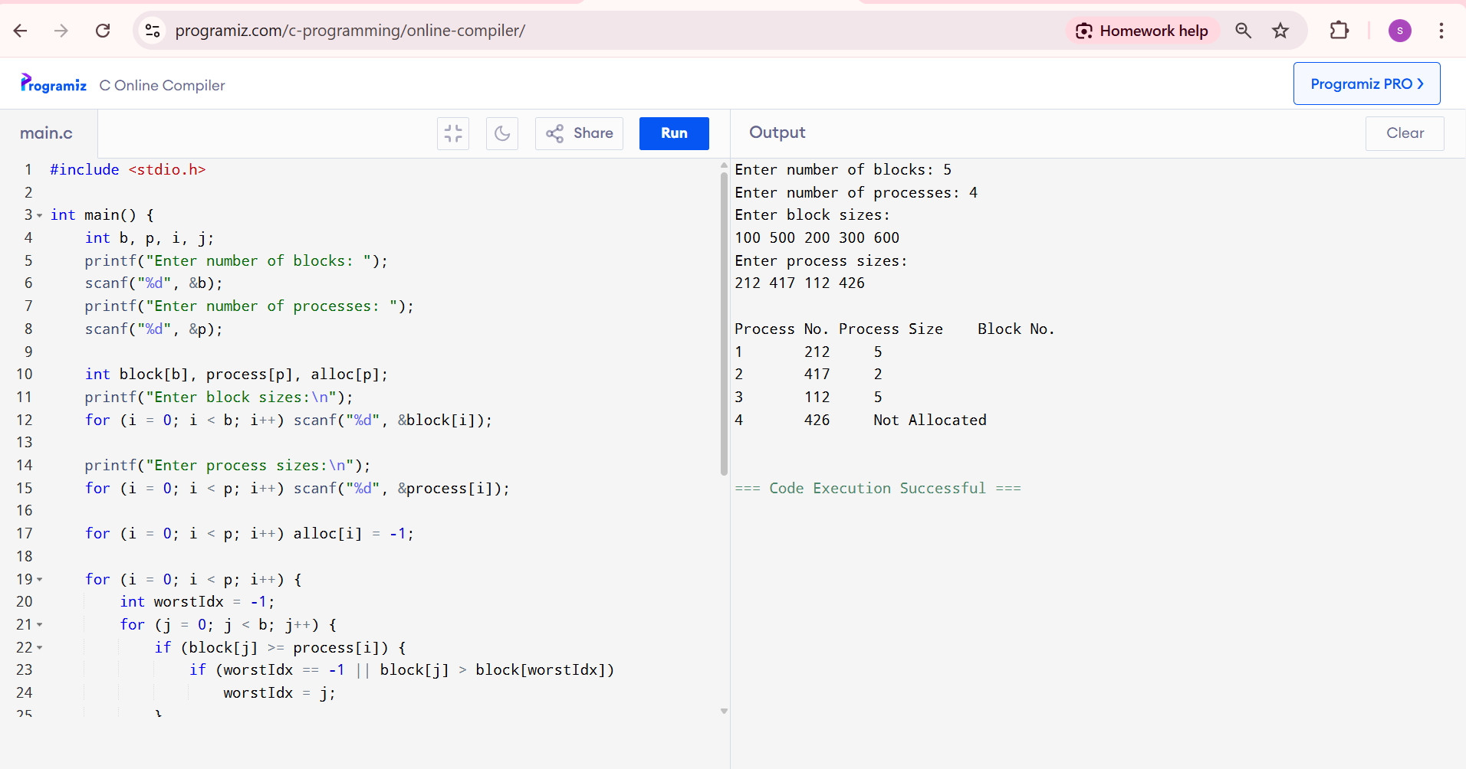

22. Construct a C program to implement best fit algorithm of memory management.

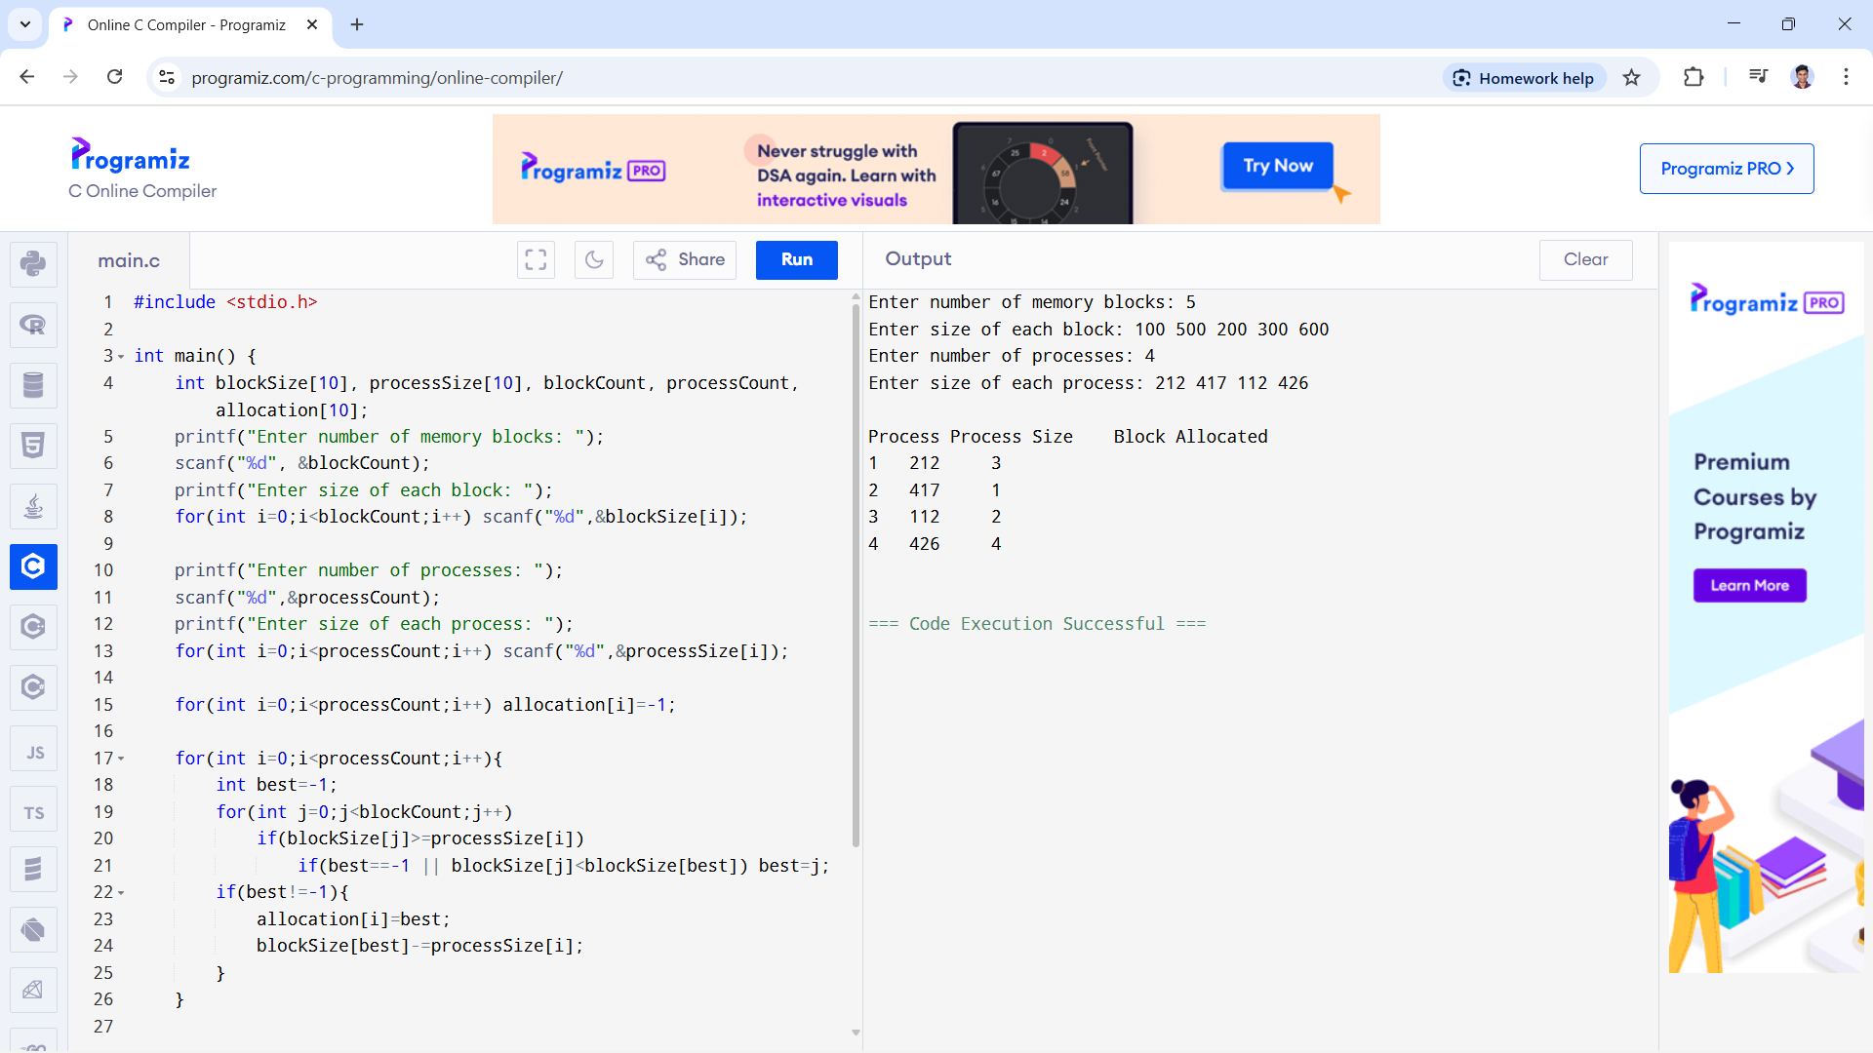

23. Construct a C program to implement first fit algorithm of memory management.

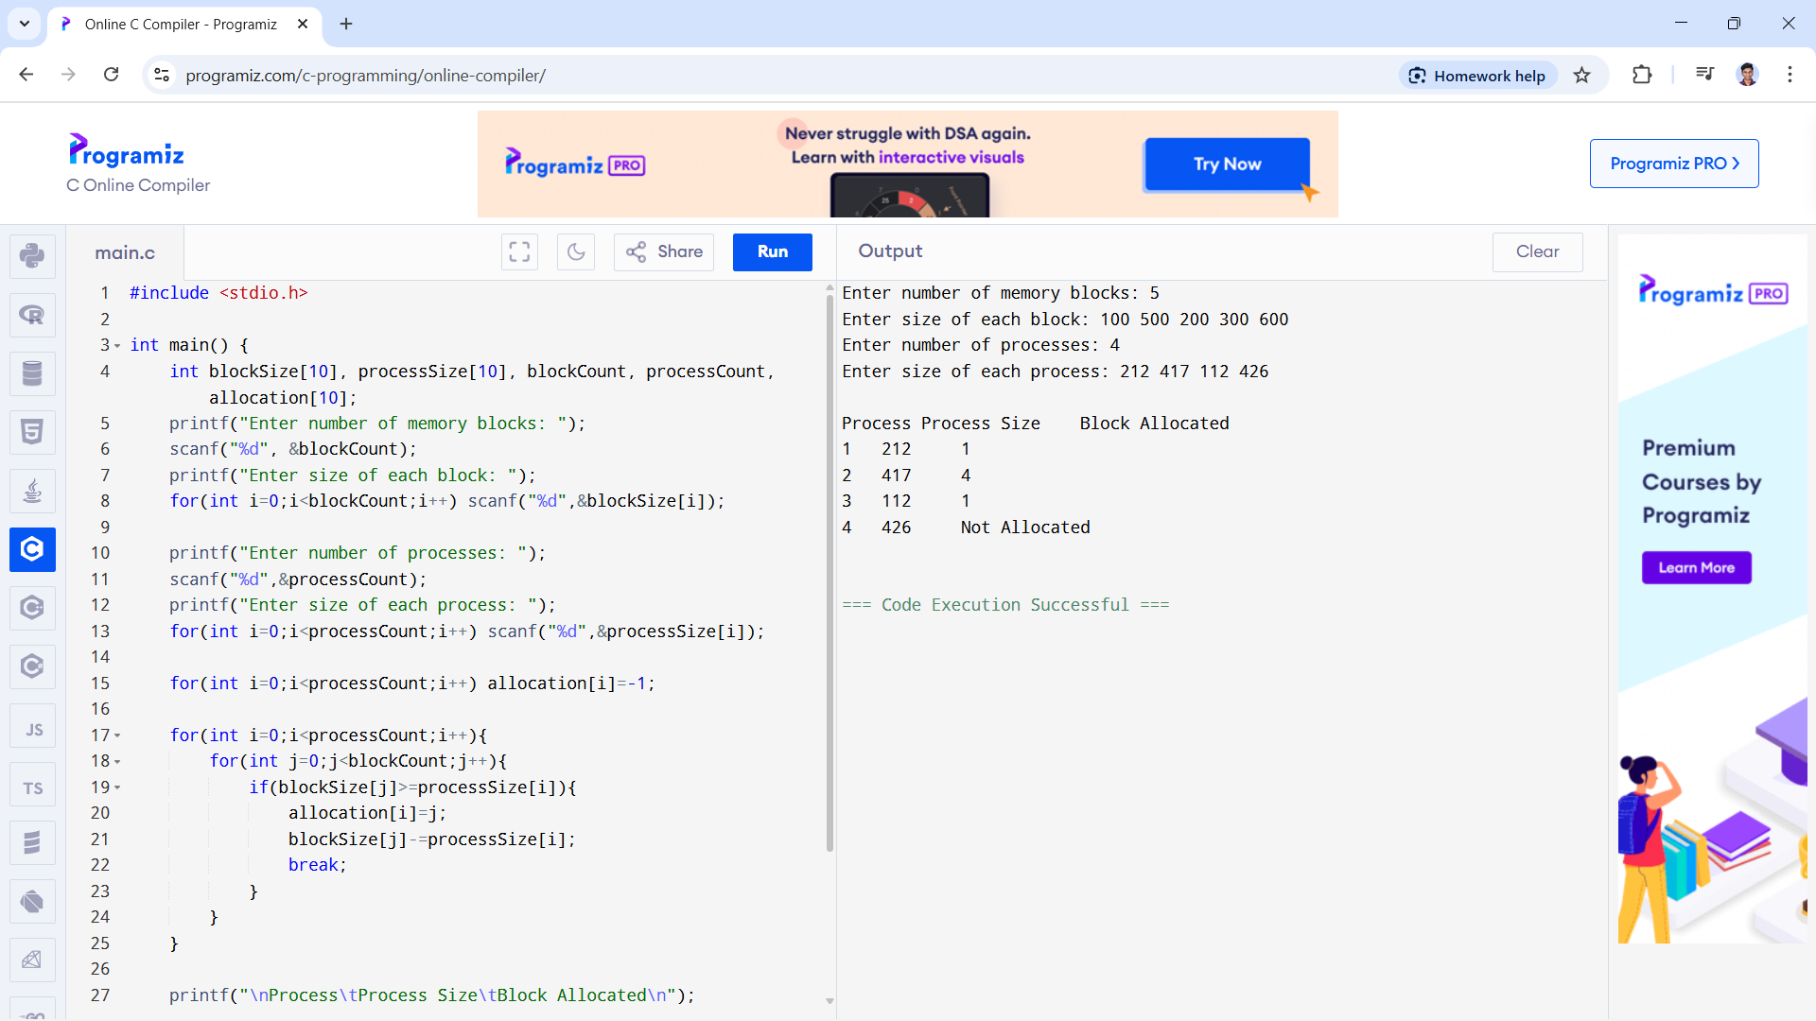

24. Design a C program to demonstrate UNIX system calls for file management.

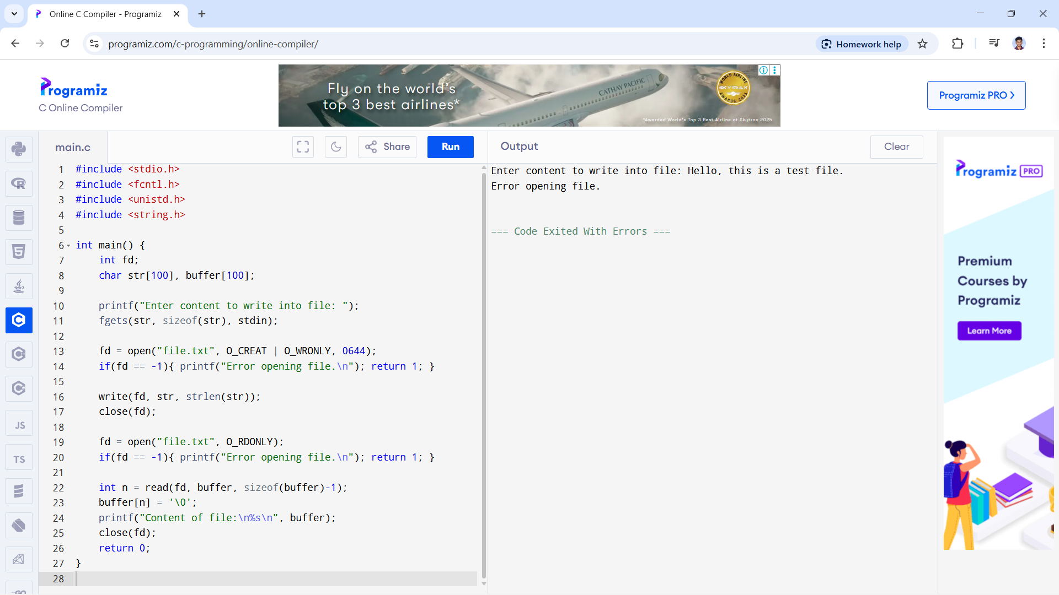

25. Construct a C program to implement the I/O system calls of UNIX (fcntl, seek, stat, opendir,

readdir)

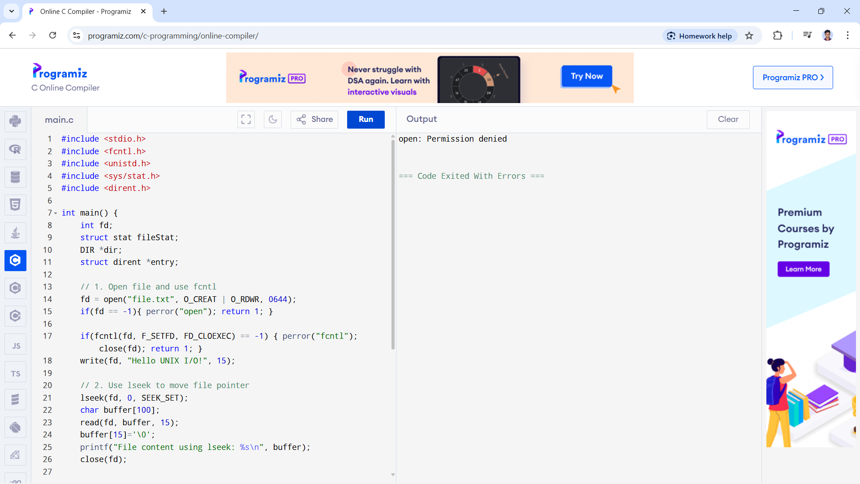

26. Construct a C program to implement the file management operations.

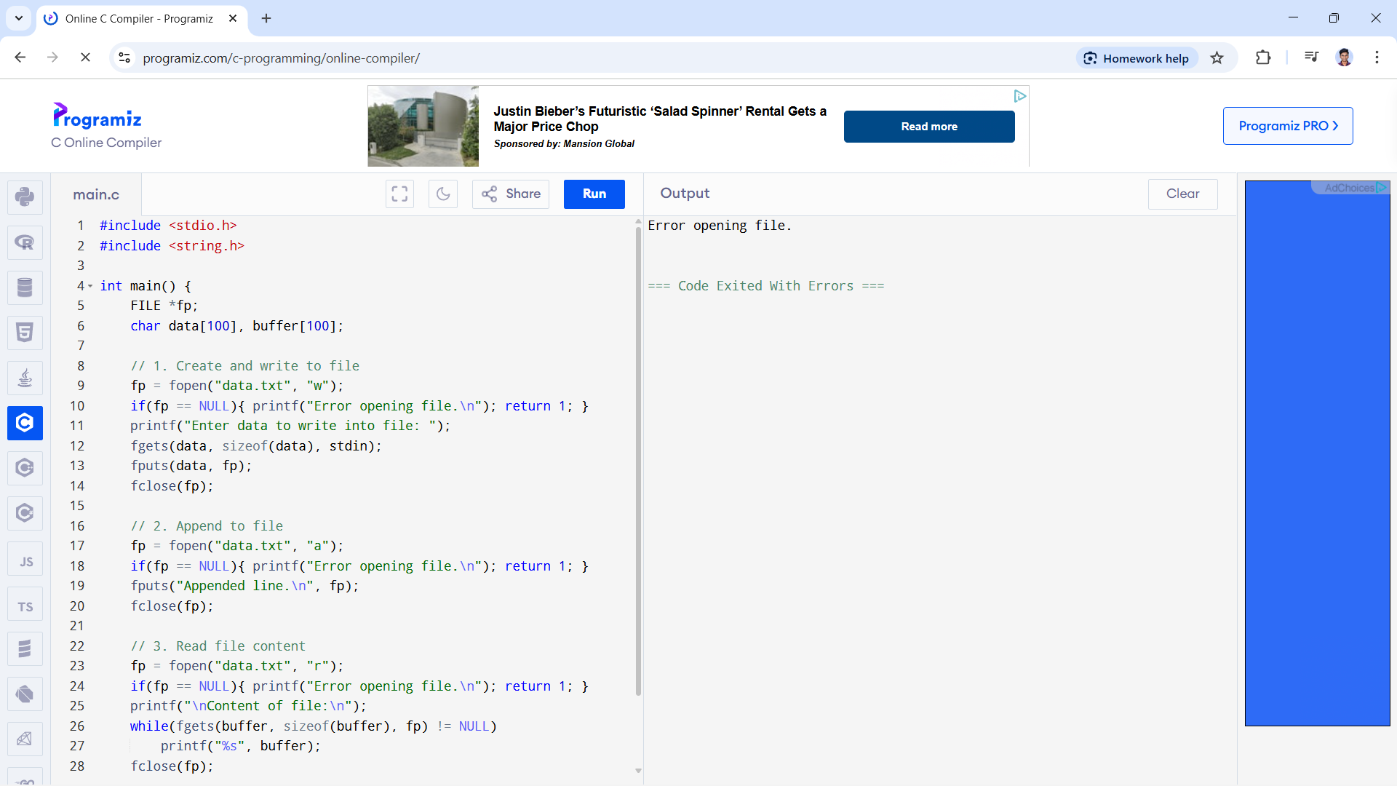

27. Develop a C program for simulating the function of ls UNIX Command.

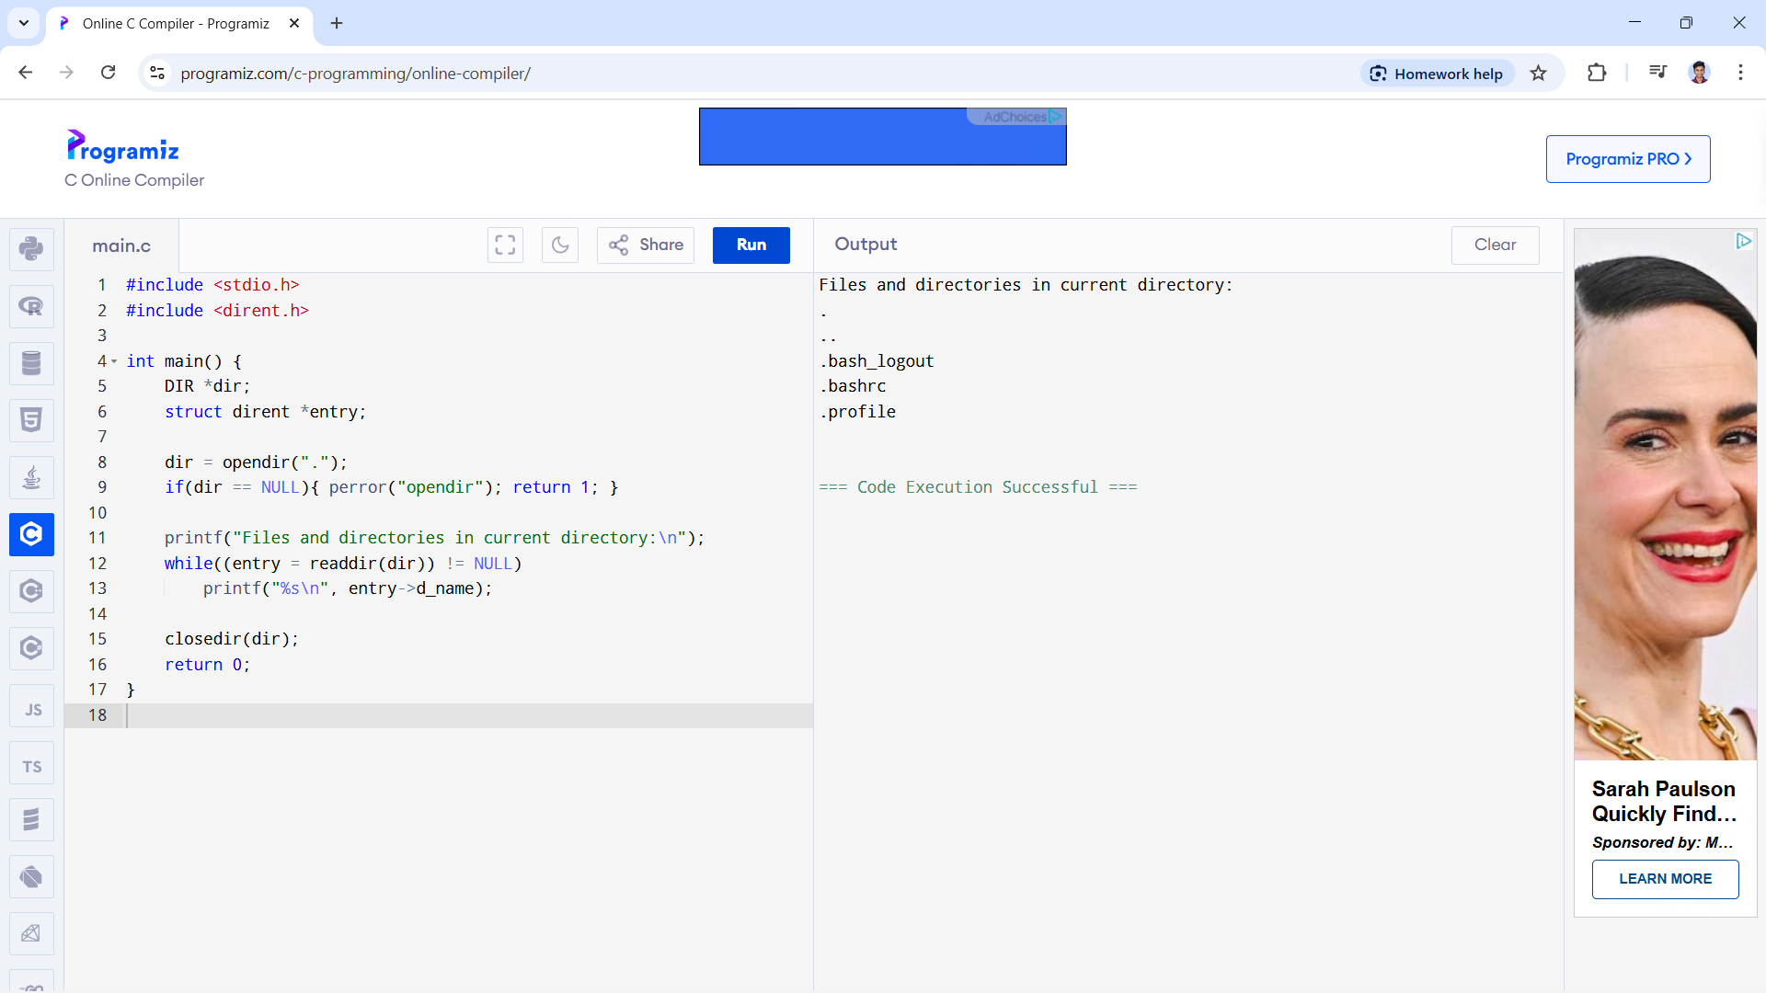

28. Write a C program for simulation of GREP UNIX command

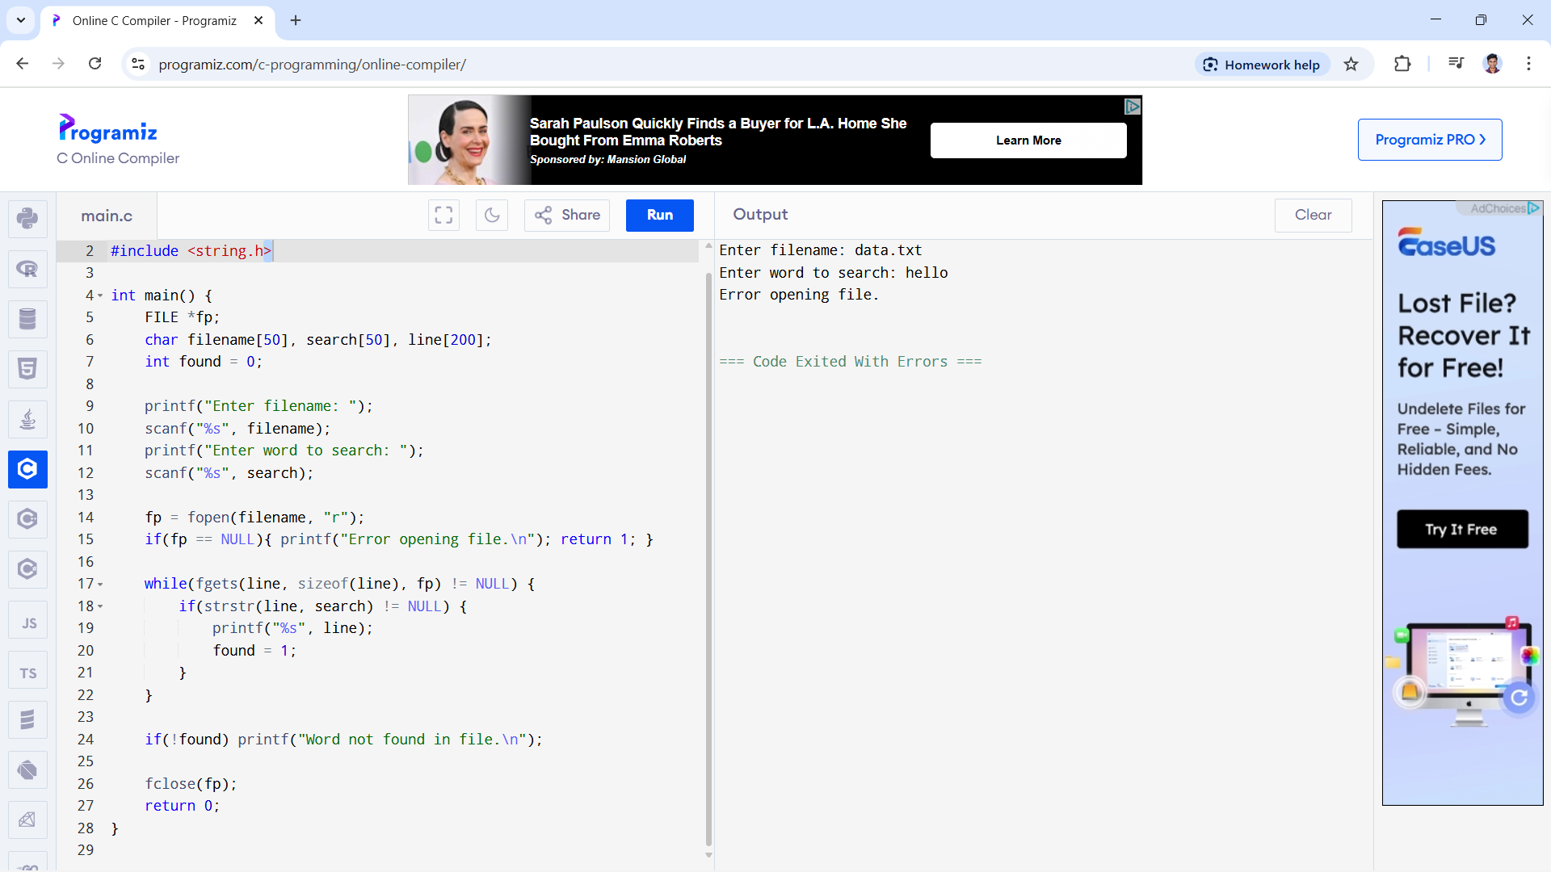

29. Write a C program to simulate the solution of Classical Process Synchronization Problem

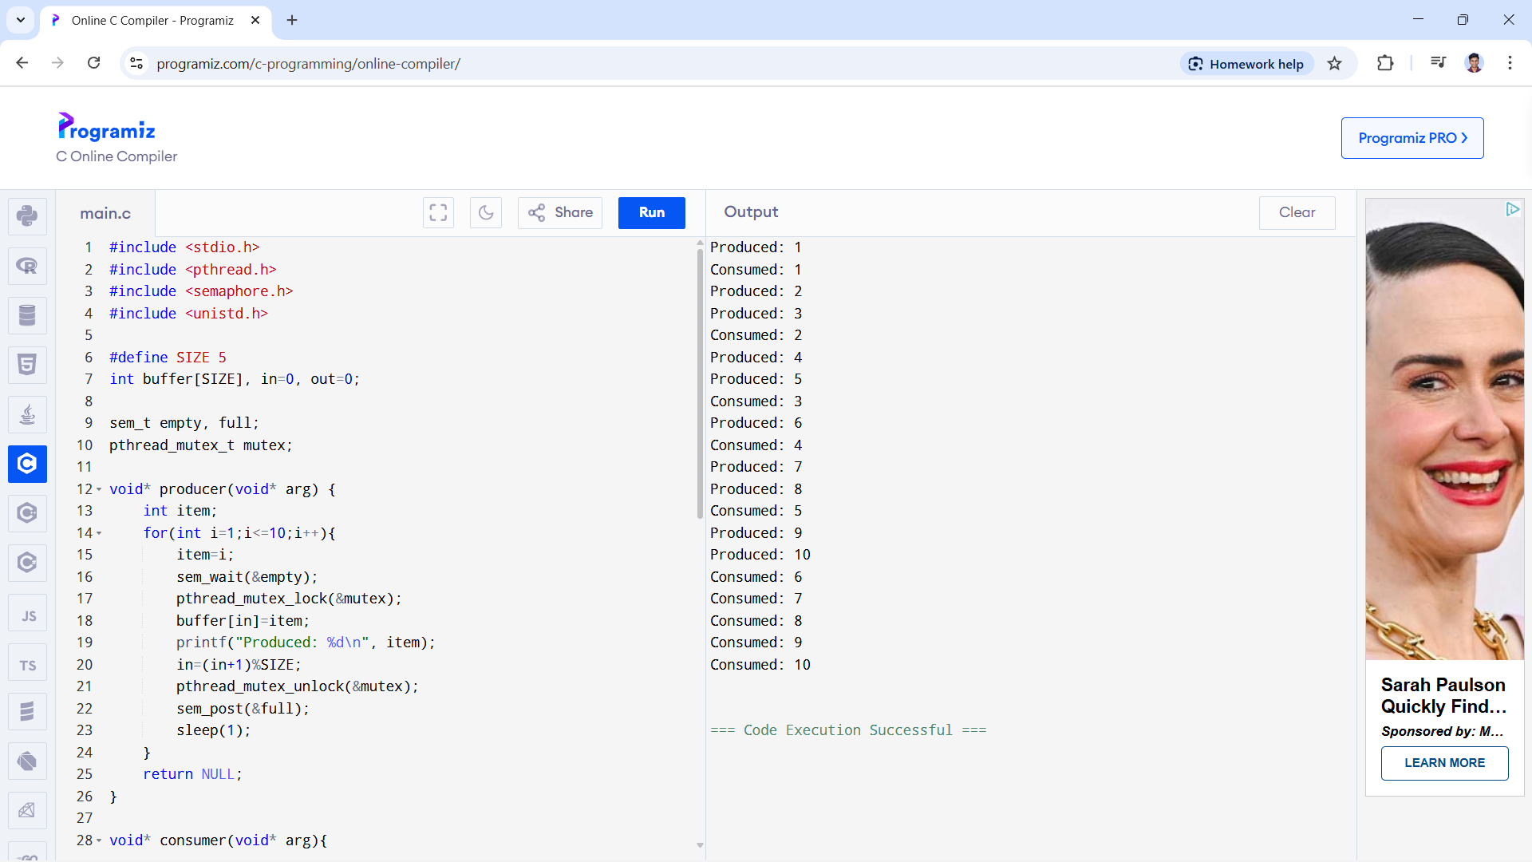

30. Write C programs to demonstrate the following thread related concepts.

(i) create (ii) join (iii) equal (iv) exit

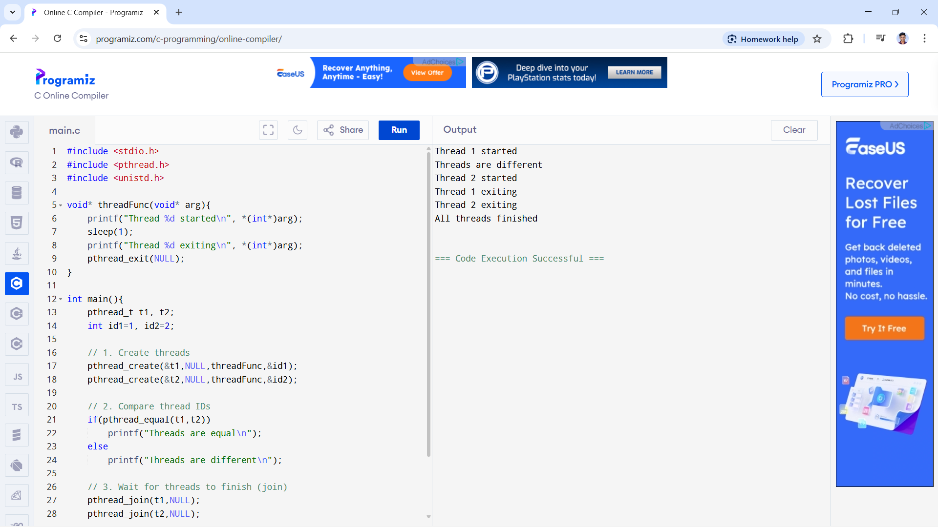

31. Construct a C program to simulate the First in First Out paging technique of memory

management.

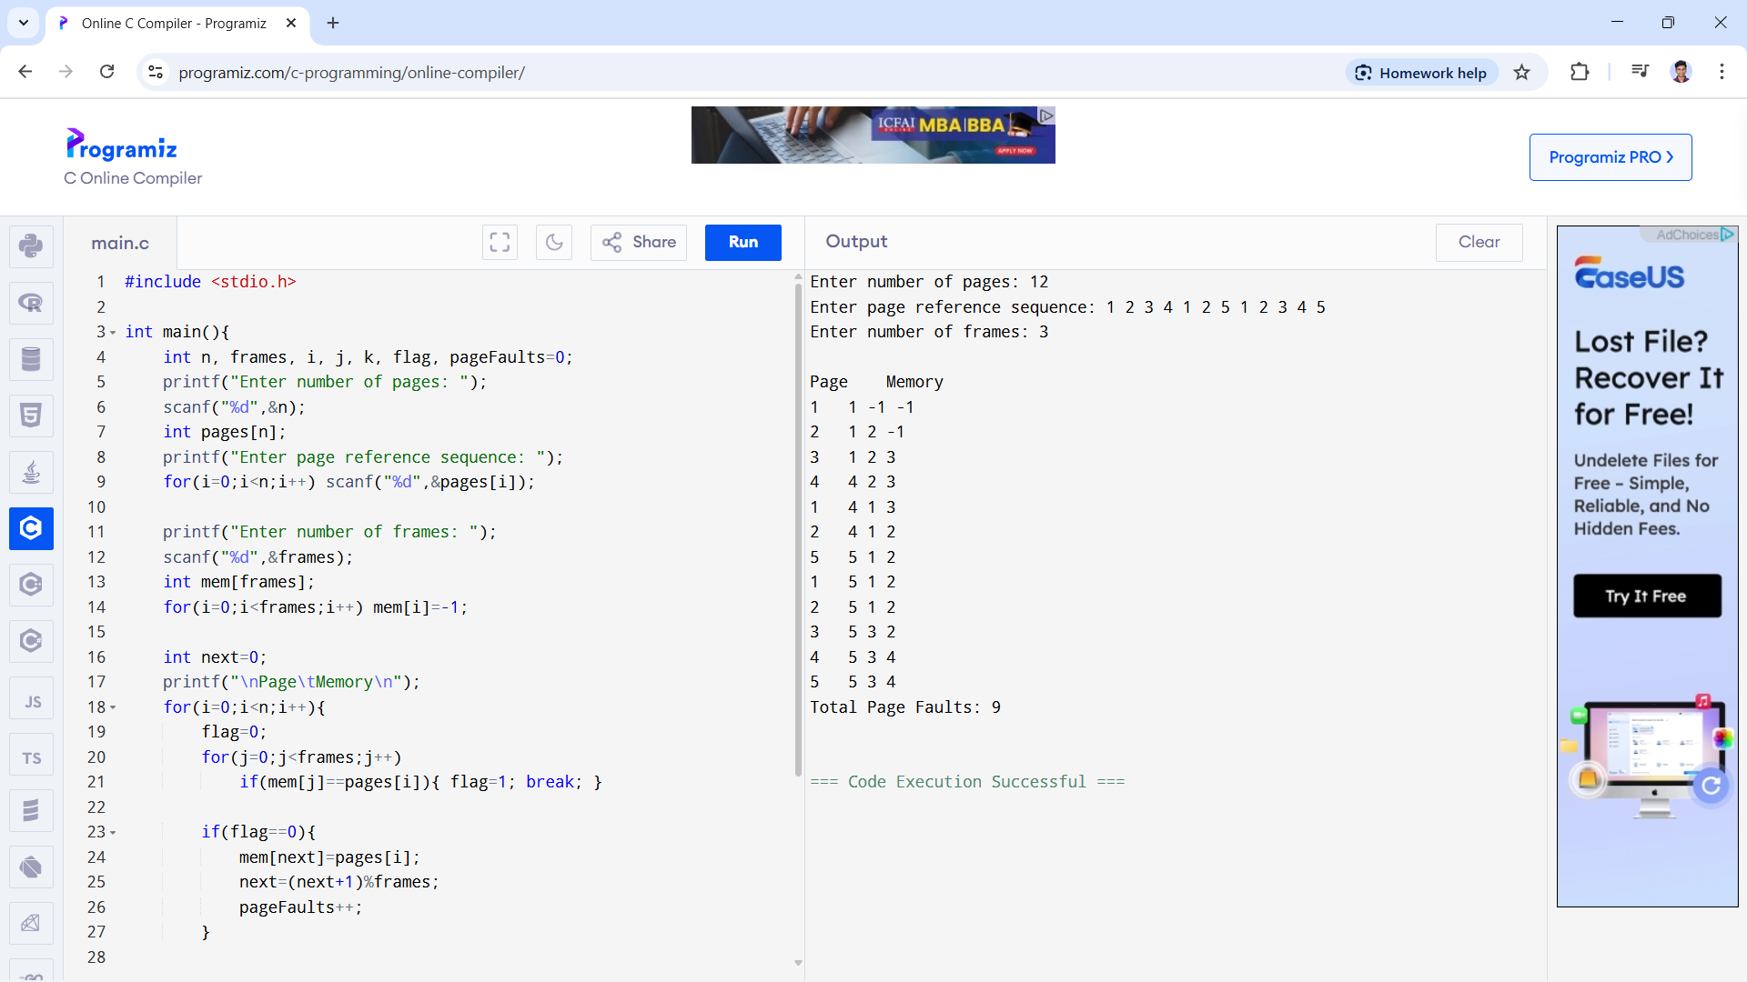

32. Construct a C program to simulate the Least Recently Used paging technique of memory

management.

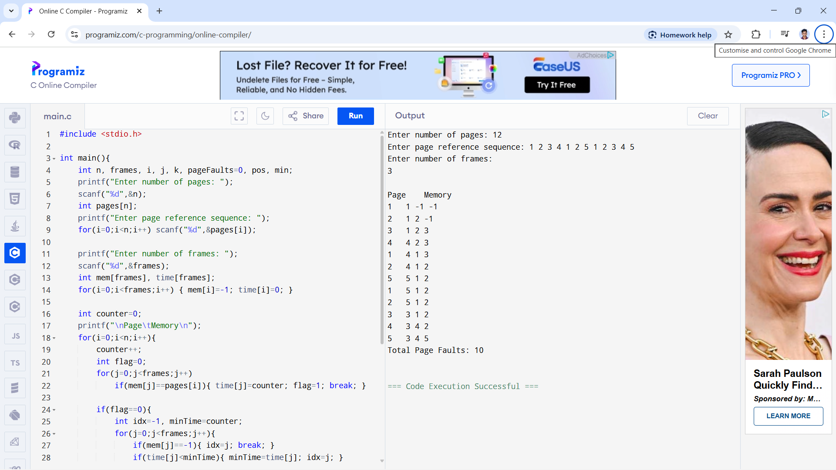

33. Construct a C program to simulate the optimal paging technique of memory management

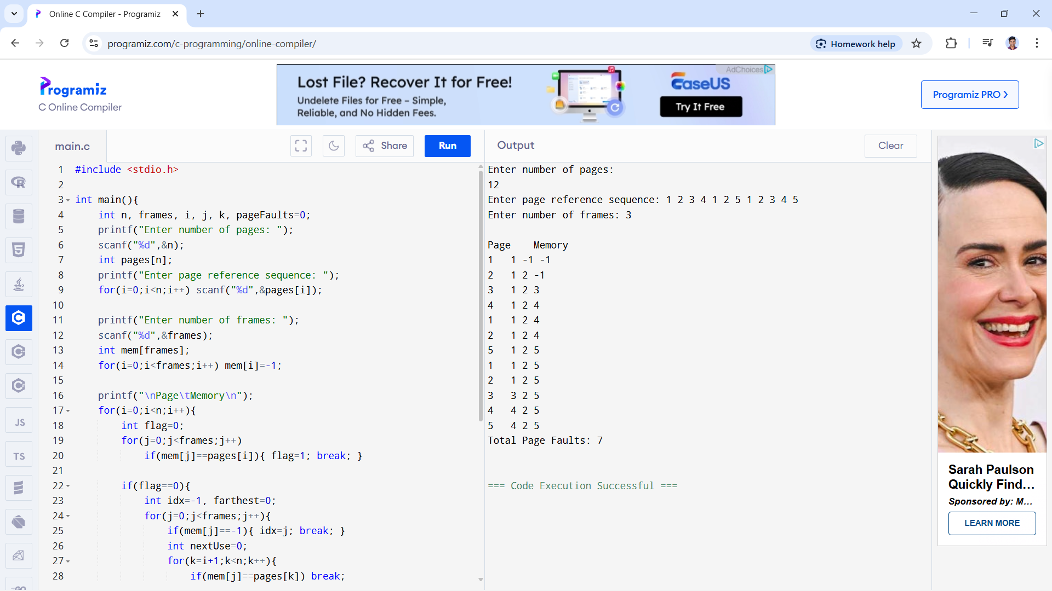

34. Consider a file system where the records of the file are stored one after another both physically

and logically. A record of the file can only be accessed by reading all the previous

records. Design a C program to simulate the file allocation strategy.

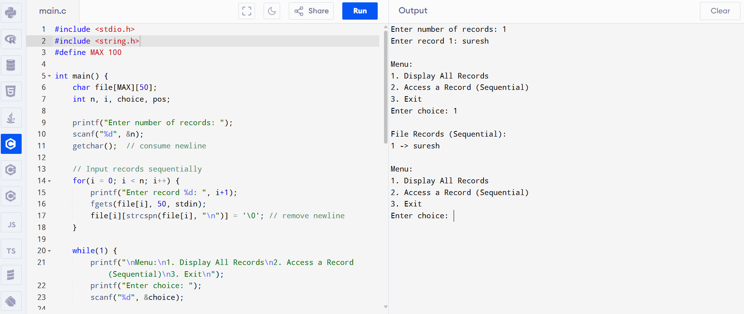

35. Consider a file system that brings all the file pointers together into an index block. The ith

entry in the index block points to the ith block of the file. Design a C program to simulate the file

allocation strategy.

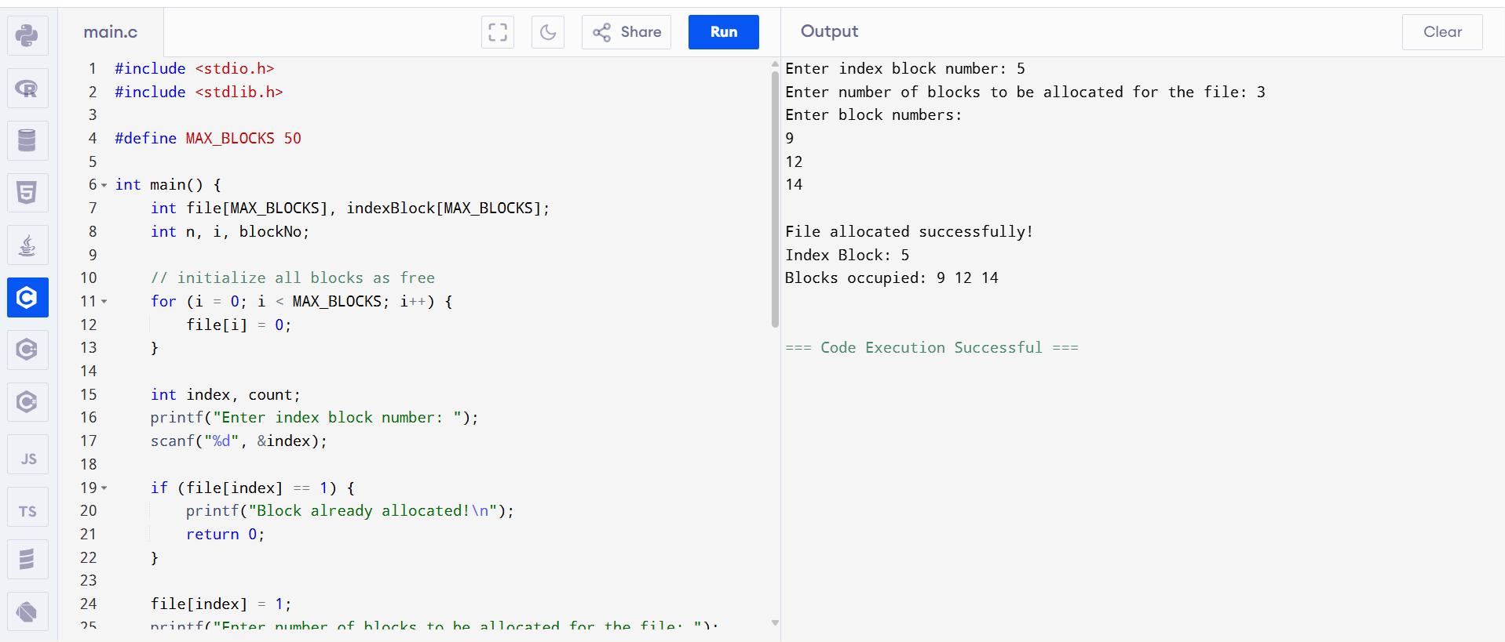

36. With linked allocation, each file is a linked list of disk blocks; the disk blocks may be scattered

anywhere on the disk. The directory contains a pointer to the first and last blocks of the file. Each

block contains a pointer to the next block. Design a C program to simulate the file allocation

strategy.

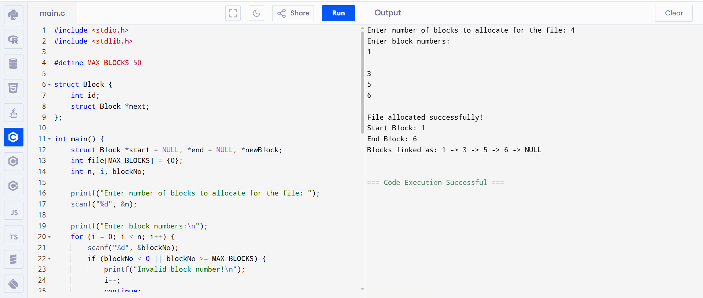

37.Construct a C program to simulate the First Come First Served disk scheduling

algorithm.

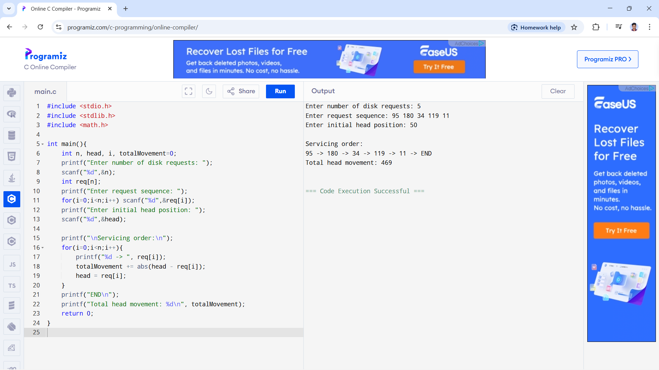

38. Design a C program to simulate SCAN disk scheduling algorithm.

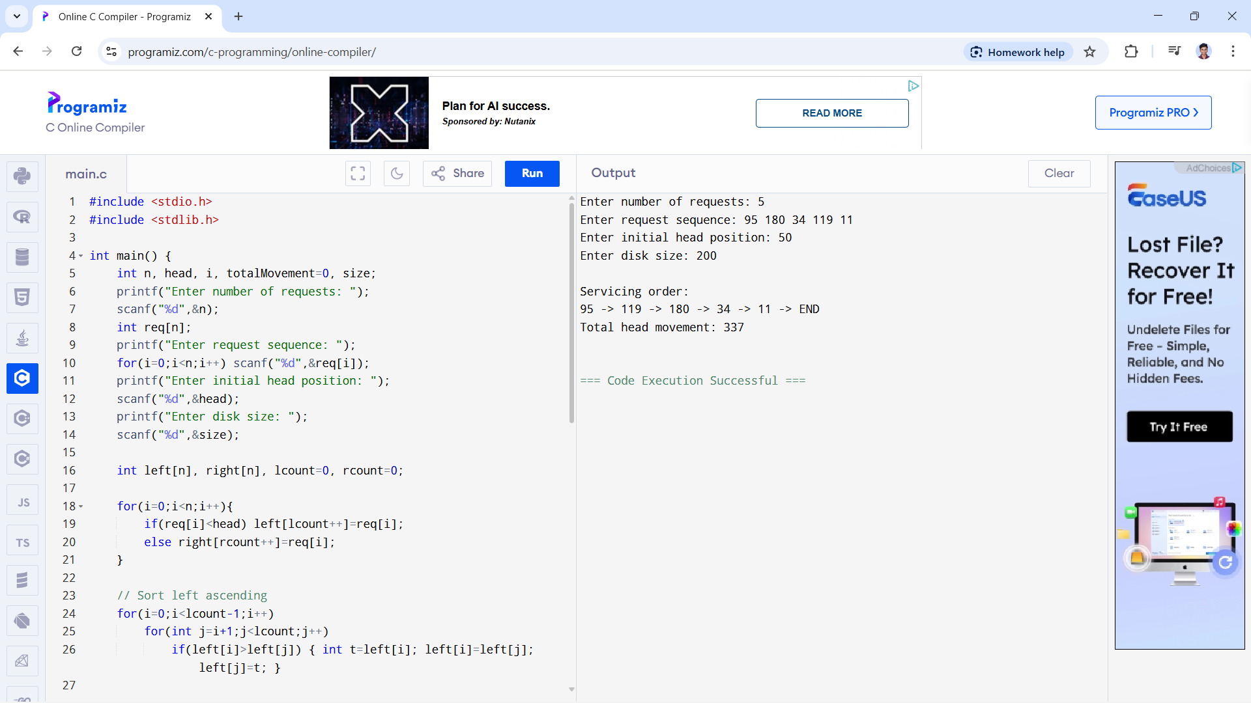

39. Develop a C program to simulate C-SCAN disk scheduling algorithm.

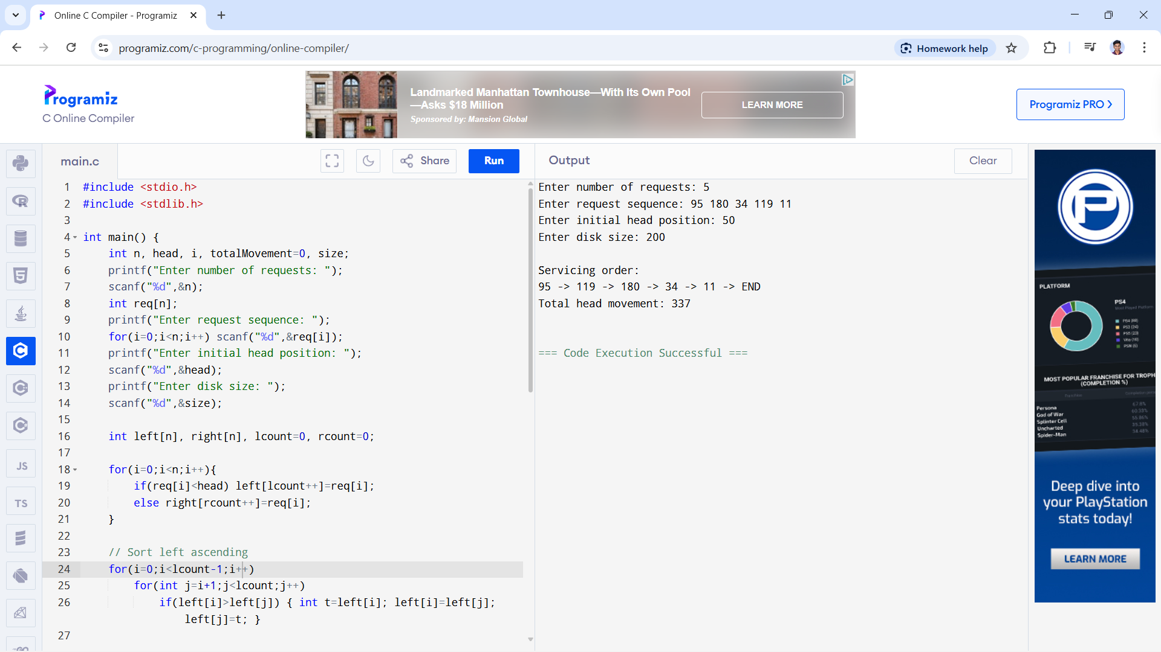

40. Illustrate the various File Access Permission and different types users in Linux.

